Chapter 12, Problem 26.

Using Fig. 12.55, design a problem to help other students better understand balanced delta connected sources delivering power to balanced wye connected loads.
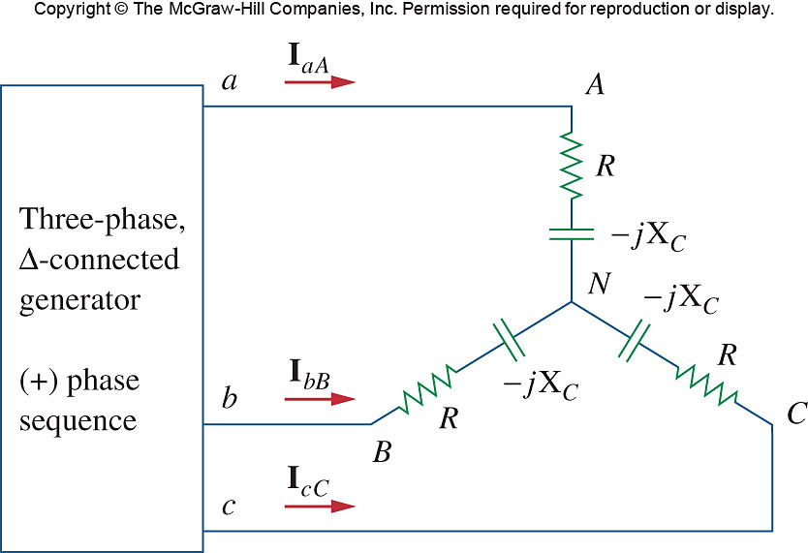

Figure 12.55
For Prob. 12.26.

